Accounts Project

* **Project Members:** Zain Saqib , Sheikh Abdul Moiz ,Shubair Hyder, Zubair Ahmed, Muhammad Awais Sheikh
* **Project Member Ids:** 23k0588,
* **Section:** 3-c
* **Teacher:** Sir Jehangir
* D
* D
* D
* Dd

# TABLE OF CONTENTS

Accounts Project 0

TABLE OF CONTENTS 1

INTRODUCTION 2

DESCRIPTION OF BUISNESS 2

CAPITAL BUDGETING 2

CHART OF ACCOUNTS 3

Assets (100-199) 3

Liabilities (200-299) 3

Expenses (300-399) 3

Capital (400-499) 4

Revenue (500-599) 4

GENERAL JOURNAL 5

T-ACCOUNTS 12

TRIAL BALANCE 22

ADJUSTING ENTRIES AND ADJUSTED TRIAL BALANCE 23

Adjusting Entries 23

Adjusted Trial Balance 24

FINANCIAL STATEMENTS 25

INCOME STATEMENT 25

OWNER’S EQUITY STATEMENT 26

BALANCE SHEET 27

CLOSING ENTRIES ,T-Accounts AND POST-CLOSING TRIAL BALANCE 28

Closing Entries 28

Closing T-Accounts 29

Post-Closing Trial Balance 30

# INTRODUCTION

## DESCRIPTION OF BUSINESS

SecureWala is a cybersecurity audit firm established on August 1, 2024, providing a range of services to businesses and government agencies. The firm is co-owned by three partners, specializing in cybersecurity audits, risk assessments, and IT security consulting. SecureWala is dedicated to helping clients secure their digital infrastructure through comprehensive audit services, ensuring they comply with the latest cybersecurity standards.

The company has made strategic investments in technology and infrastructure to support its growing operations. Early investments included the purchase of laptops, office equipment, and software, as well as securing a well-equipped office space. The firm has also subscribed to essential tools, including cybersecurity software and accounting systems, to ensure smooth business operations.

SecureWala's team consists of highly skilled professionals, including cybersecurity analysts who were hired shortly after the firm’s inception. These employees play a crucial role in delivering cybersecurity audits to the firm's clients. In addition, the firm invests in employee development through regular training sessions, enhancing its team's expertise to stay ahead in the ever-evolving cybersecurity landscape.

As part of its operational setup, SecureWala also maintains an online presence through marketing campaigns to reach a broader audience, while continuously managing costs such as office utilities and maintenance. The firm has secured its first few contracts, with clients paying upfront portions of audit fees, demonstrating a growing demand for its services.

The company's growth is supported by regular investments in infrastructure, marketing, and human resources, ensuring it remains competitive and efficient in the cybersecurity audit industry.

### 

### CAPITAL BUDGETING

To establish SecureWala, we decided to invest an initial budget of $150,000. Anticipating that this amount would cover our startup needs effectively.

Here’s a breakdown of our starting budget (required to effectively start a business):

**INITIAL INVESTMENT REQUIRED TO START THE BUSINESS: 150000**

Below is how 150000 as a starting budget is divided among the following.

1. **RENT EXPENDITURE**

[Includes the cost of leasing office or commercial space.]

1. **INSURANCE**

[Protects the business against risks such as property damage, liability, or employee injuries.]

1. **OFFICE EQUIPMENT**

[Includes all hardware and devices essential for day-to-day operations. **Example**: Computers, printers, scanners, telephones, ergonomic furniture, and storage solutions.]

1. **INTERNET INSALLATION + YEARLY SUBSCRIPTION**

[Reliable internet is critical for communication and operations.

**Installation Costs:** Initial setup fees for hardware like routers or modems.

**Subscription Costs:** Vary based on the required speed, bandwidth, and service provider.

**Considerations:** Fiber-optic internet might cost more but offers higher reliability and speed.]

1. **SECURITY SOFTWARE LISCENSE**

[Protects the business's digital assets from cyber threats.

**Software Needs:** Antivirus, firewall solutions, malware detection, and possibly endpoint protection for remote teams.]

1. **OFFICE SUPPLIES**

[Day-to-day consumables required for smooth operations.

Examples: Stationery (pens, paper, notebooks), cleaning supplies, printer ink, coffee/tea, etc.]

1. **UTILITIES**

[Covers essential services for running the office.

Examples: Electricity, water, heating, air conditioning, and trash disposal.]

STARTING MONTH ANAYLSIS (CAPITAL BUDGETING)

**1. CASH INFLOWS**

* **01-Aug**: Initial cash contributed by owners: **$150,000**

**2. CASH OUTFLOWS (EXPENSES AND PAYMENTS)**

|  |  |  |
| --- | --- | --- |
| Date | Description | Amount ($) |
| 03-Aug | Prepaid rent for 1 year | 50,000 |
| 04-Aug | Prepaid insurance for 1 year | 2,000 |
| 05-Aug | Office equipment (computers, desks, etc.) | 15,000 |
| 07-Aug | Internet installation | 200 |
| 07-Aug | Yearly internet subscription | 100 |
| 08-Aug | Cybersecurity software license (1 year) | 10,000 |
| 10-Aug | Office supplies | 150 |
| 31-Aug | Utilities (electricity and water) | 500 |

**TOTAL OUTFLOWS:**

50,000+2,000+15,000+200+100+10,000+150+500=77,950

**3. NET BUDGET CALCULATION**

* **Total Cash Inflows:** $150,000
* **Total Cash Outflows:** $77,950

**REMAINING BUDGET:** $72,050

[NOTE]: Remaining budget will be allocated to employees (hiring and their salaries)

OVERVIEW (FOR THE REMAINING YEAR):

Keeping track for next months based on revenues and expenses, budget will be allocated accordingly to various sectors of employment to effectively keep the business running. This budget will subsequently be adjusted (deducted based on expenses, growth based on income and revenue) accordibly.

# CHART OF ACCOUNTS

## Assets (100-199)

100: Cash

110: Accounts Receivable

120: Prepaid Rent

121: Prepaid Insurance

130: Office Furniture

131: Office Supplies

140: Equipment (Laptops)

150: Security System

## Liabilities (200-299)

200: Accounts Payable

210: Unearned Revenue

220: Accumulated Depreciation-Equipment

230: Accumulated Depreciation-Office Furniture

## Expenses (300-399)

300: Office Supplies Expense

310: Office Expense

320: Utilities Expense

330: Marketing Expense

340: Training Expense

350: Maintenance Expense

360: Meals and Entertainment Expense

361: Bonus Expense

362: Licensing Expense

370: Salaries Expense

380: Software Expense

381: Insurance Expense

382: Rent Expense

383: Depreciation Expense-Equipment

384: Depreciation Expense-Office Furniture

385: Advertisement Expense

390: Travel and Meals Expense

391: Legal Expense

392: Professional Fees Expense

## Capital (400-499)

400: Capital

410: Owner's Drawings

## Revenue (500-599)

500: Service Revenue

# GENERAL JOURNAL

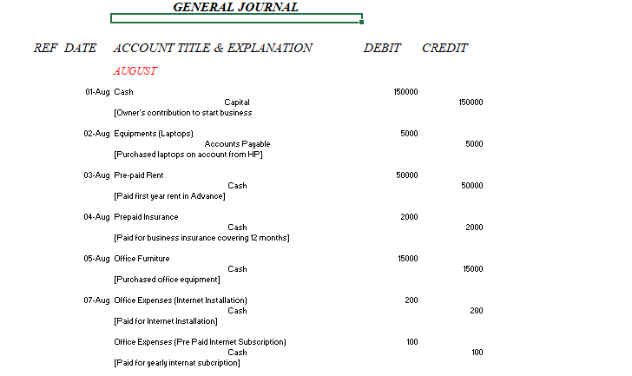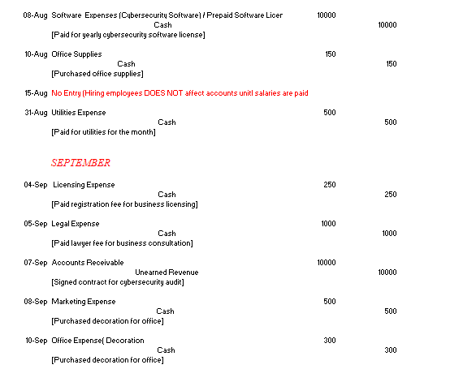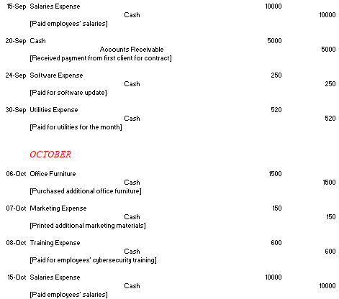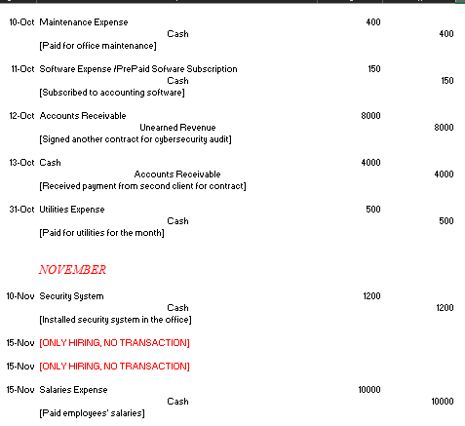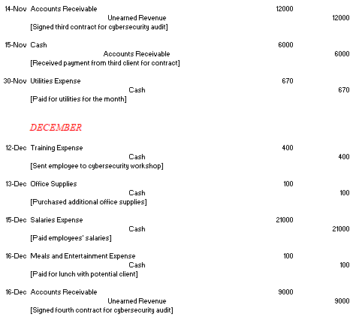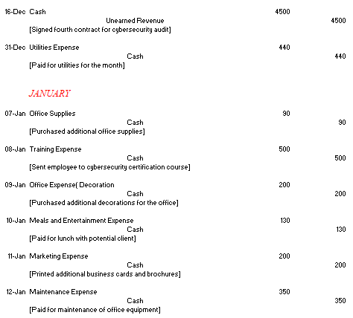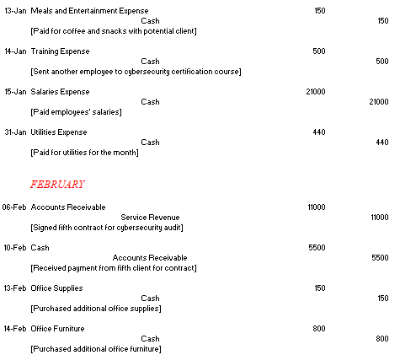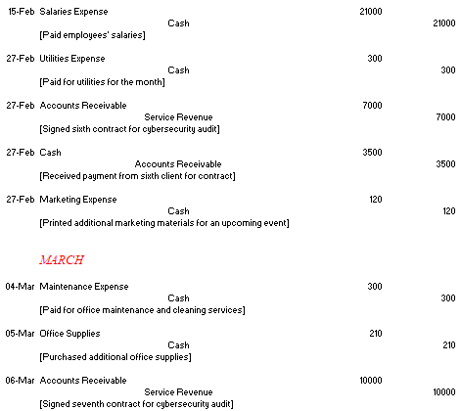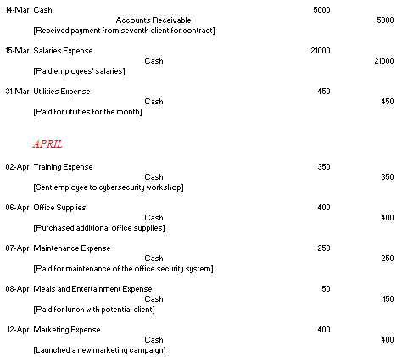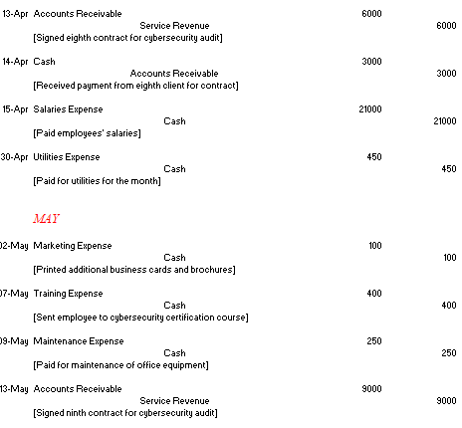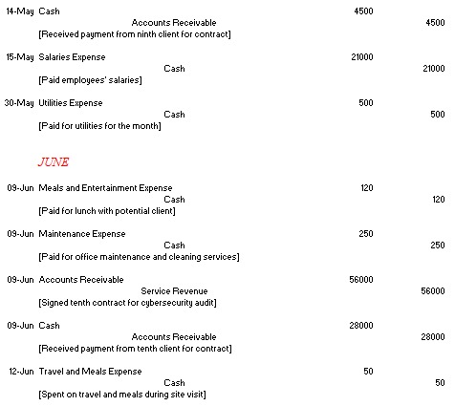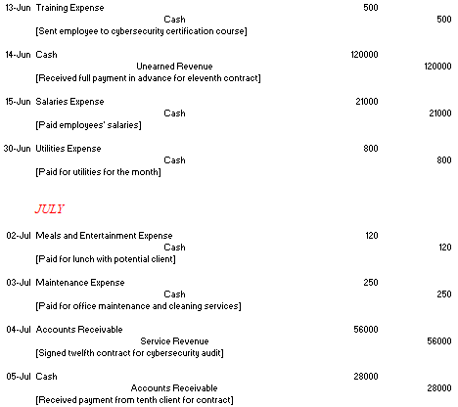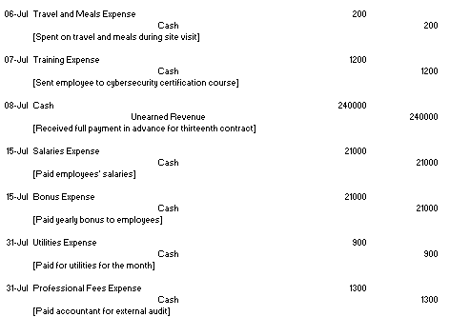

# T-ACCOUNTS

|  |  |  |  |  |  |  |  |  |  |  |
| --- | --- | --- | --- | --- | --- | --- | --- | --- | --- | --- |
|  | | | | ***Cash*** | | | | | | |
| **Date** | | | | **Debit** | | | | | **Credit** | |
| 1-Aug | | | | $150,000 | | | | |  | |
| 3-Aug | | | |  | | | | | $50,000 | |
| 4-Aug | | | |  | | | | | $2,000 | |
| 5-Aug | | | |  | | | | | $15,000 | |
| 7-Aug | | | |  | | | | | $200 | |
| 7-Aug | | | |  | | | | | $100 | |
| 8-Aug | | | |  | | | | | $10,000 | |
| 10-Aug | | | |  | | | | | $150 | |
| 31-Aug | | | |  | | | | | $500 | |
| 4-Sep | | | |  | | | | | $250 | |
| 5-Sep | | | |  | | | | | $1,000 | |
| 8-Sep | | | |  | | | | | $500 | |
| 10-Sep | | | |  | | | | | $300 | |
| 15-Sep | | | |  | | | | | $10,000 | |
| 20-Sep | | | | $5,000 | | | | |  | |
| 24-Sep | | | |  | | | | | $250 | |
| 30-Sep | | | |  | | | | | $520 | |
| 6-Oct | | | |  | | | | | $1,500 | |
| 7-Oct | | | |  | | | | | $150 | |
| 8-Oct | | | |  | | | | | $600 | |
| 10-Oct | | | |  | | | | | $400 | |
| 11-Oct | | | |  | | | | | $150 | |
| 13-Oct | | | | $4,000 | | | | |  | |
| 15-Oct | | | |  | | | | | $10,000 | |
| 31-Oct | | | |  | | | | | $500 | |
| 10-Nov | | | |  | | | | | $1,200 | |
| 15-Nov | | | | $6,000 | | | | |  | |
| 15-Nov | | | |  | | | | | $10,000 | |
| 30-Nov | | | |  | | | | | $670 | |
| 12-Dec | | | |  | | | | | $400 | |
| 13-Dec | | | |  | | | | | $100 | |
| 15-Dec | | | |  | | | | | $21,000 | |
| 16-Dec | | | | $4,500 | | | | |  | |
| 16-Dec | | | |  | | | | | $100 | |
| 31-Dec | | | |  | | | | | $440 | |
| 7-Jan | | | |  | | | | | $90 | |
| 8-Jan | | | |  | | | | | $500 | |
| 9-Jan | | | |  | | | | | $200 | |
| 10-Jan | | | |  | | | | | $130 | |
| 11-Jan | | | |  | | | | | $200 | |
| 12-Jan | | | |  | | | | | $350 | |
| 13-Jan | | | |  | | | | | $150 | |
| 14-Jan | | | |  | | | | | $500 | |
| 15-Jan | | | |  | | | | | $21,000 | |
| 31-Jan | | | |  | | | | | $440 | |
| 10-Feb | | | | $5,500 | | | | |  | |
| 13-Feb | | | |  | | | | | $150 | |
| 14-Feb | | | |  | | | | | $800 | |
| 15-Feb | | | |  | | | | | $21,000 | |
| 27-Feb | | | | $3,500 | | | | |  | |
| 27-Feb | | | |  | | | | | $300 | |
| 27-Feb | | | |  | | | | | $120 | |
| 4-Mar | | | |  | | | | | $300 | |
| 5-Mar | | | |  | | | | | $210 | |
| 14-Mar | | | | $5,000 | | | | |  | |
| 15-Mar | | | |  | | | | | $21,000 | |
| 31-Mar | | | |  | | | | | $450 | |
| 2-Apr | | | |  | | | | | $350 | |
| 6-Apr | | | |  | | | | | $400 | |
| 7-Apr | | | |  | | | | | $250 | |
| 8-Apr | | | |  | | | | | $150 | |
| 12-Apr | | | |  | | | | | $400 | |
| 14-Apr | | | | $3,000 | | | | |  | |
| 15-Apr | | | |  | | | | | $21,000 | |
| 30-Apr | | | |  | | | | | $450 | |
| 2-May | | | |  | | | | | $100 | |
| 7-May | | | |  | | | | | $400 | |
| 9-May | | | |  | | | | | $250 | |
| 14-May | | | | $4,500 | | | | |  | |
| 15-May | | | |  | | | | | $21,000 | |
| 30-May | | | |  | | | | | $500 | |
| 9-Jun | | | | $28,000 | | | | |  | |
| 9-Jun | | | |  | | | | | $120 | |
| 9-Jun | | | |  | | | | | $250 | |
| 12-Jun | | | |  | | | | | $50 | |
| 13-Jun | | | |  | | | | | $500 | |
| 14-Jun | | | | $120,000 | | | | |  | |
| 15-Jun | | | |  | | | | | $21,000 | |
| 30-Jun | | | |  | | | | | $800 | |
| 2-Jul | | | |  | | | | | $120 | |
| 3-Jul | | | |  | | | | | $250 | |
| 5-Jul | | | | $28,000 | | | | |  | |
| 6-Jul | | | |  | | | | | $200 | |
| 7-Jul | | | |  | | | | | $1,200 | |
| 8-Jul | | | | $240,000 | | | | |  | |
| 15-Jul | | | |  | | | | | $21,000 | |
| 15-Jul | | | |  | | | | | $21,000 | |
| 31-Jul | | | |  | | | | | $900 | |
| 31-Jul | | | |  | | | | | $1,300 | |
|  | | | | **$287,190** | | | | |  | |
|  | | | |  | | | | |  | |
| **ACCOUNTS RECEIVABLE** | | | | | | | | | | | | | | | | |
| **Date** | | | | | **Debit** | | **Credit** | | | | | | | |  | |
| 7-Sep | | | | | $10,000 | |  | | | | | | | |  | |
| 20-Sep | | | | |  | | $5,000 | | | | | | | |  | |
| 12-Oct | | | | | $8,000 | |  | | | | | | | |  | |
| 13-Oct | | | | |  | | $4,000 | | | | | | | |  | |
| 14-Nov | | | | | $12,000 | |  | | | | | | | |  | |
| 15-Nov | | | | |  | | $6,000 | | | | | | | |  | |
| 16-Dec | | | | | $9,000 | |  | | | | | | | |  | |
| 6-Feb | | | | | $11,000 | |  | | | | | | | |  | |
| 10-Feb | | | | |  | | $5,500 | | | | | | | |  | |
| 27-Feb | | | | | $7,000 | |  | | | | | | | |  | |
| 27-Feb | | | | |  | | $3,500 | | | | | | | |  | |
| 6-Mar | | | | | $10,000 | |  | | | | | | | |  | |
| 14-Mar | | | | |  | | $5,000 | | | | | | | |  | |
| 13-Apr | | | | | $6,000 | |  | | | | | | | |  | |
| 14-Apr | | | | |  | | $3,000 | | | | | | | |  | |
| 13-May | | | | | $9,000 | |  | | | | | | | |  | |
| 14-May | | | | |  | | $4,500 | | | | | | | |  | |
| 9-Jun | | | | | $56,000 | |  | | | | | | | |  | |
| 9-Jun | | | | |  | | $28,000 | | | | | | | |  | |
| 4-Jul | | | | | $56,000 | |  | | | | | | | |  | |
| 5-Jul | | | | |  | | $28,000 | | | | | | | |  | |
|  | | | | |  | | **$101,500** | | | | | | | |  | |
|  | | | | |  | |  | | | | | | | |  | |
| **UNEARNED REVENUE** | | | | | | | | | | | | |
| **Date** | | | **Debit** | | | **Credit** | | | | | | |
| 7-Sep | | |  | | | $10,000 | | | | | | |
| 12-Oct | | |  | | | $8,000 | | | | | | |
| 14-Nov | | |  | | | $12,000 | | | | | | |
| 16-Dec | | |  | | | $9,000 | | | | | | |
| 16-Dec | | |  | | | $4,500 | | | | | | |
| 14-Jun | | |  | | | $120,000 | | | | | | |
| 8-Jul | | |  | | | $240,000 | | | | | | |
|  | | |  | | | **$403,500** | | | | | | |
|  | | |  | | |  | | | | | | |
| **SERVICE REVENUE** | | | | | | | | | | | | |
| **Date** | | | **Debit** | | | **Credit** | | | | | | |
| 6-Feb | | |  | | | $11,000 | | | | | | |
| 27-Feb | | |  | | | $7,000 | | | | | | |
| 6-Mar | | |  | | | $10,000 | | | | | | |
| 13-Apr | | |  | | | $6,000 | | | | | | |
| 13-May | | |  | | | $9,000 | | | | | | |
| 9-Jun | | |  | | | $56,000 | | | | | | |
| 4-Jul | | |  | | | $56,000 | | | | | | |
|  | | |  | | | **$155,000** | | | | | | |
|  | | |  | | |  | | | | | | |
| **SALARIES EXPENSE** | | | | | | | | | | | | | |
| **Date** | | **Debit** | | | | | | | | **Credit** | | | |
| 15-Sep | | $10,000 | | | | | | | |  | | | |
| 15-Oct | | $10,000 | | | | | | | |  | | | |
| 15-Nov | | $10,000 | | | | | | | |  | | | |
| 15-Dec | | $21,000 | | | | | | | |  | | | |
| 15-Jan | | $21,000 | | | | | | | |  | | | |
| 15-Feb | | $21,000 | | | | | | | |  | | | |
| 15-Mar | | $21,000 | | | | | | | |  | | | |
| 15-Apr | | $21,000 | | | | | | | |  | | | |
| 15-May | | $21,000 | | | | | | | |  | | | |
| 15-Jun | | $21,000 | | | | | | | |  | | | |
| 15-Jul | | $21,000 | | | | | | | |  | | | |
|  | | **$198,000** | | | | | | | |  | | | |
|  | |  | | | | | | | |  | | | |
| **UTILITIES EXPENSE** | | | | | | | | | | | | | |
| **Date** | | **Debit** | | | | | | | | **Credit** | | | |
| 31-Aug | | $500 | | | | | | | |  | | | |
| 30-Sep | | $520 | | | | | | | |  | | | |
| 31-Oct | | $500 | | | | | | | |  | | | |
| 30-Nov | | $670 | | | | | | | |  | | | |
| 31-Dec | | $440 | | | | | | | |  | | | |
| 31-Jan | | $440 | | | | | | | |  | | | |
| 27-Feb | | $300 | | | | | | | |  | | | |
| 31-Mar | | $450 | | | | | | | |  | | | |
| 30-Apr | | $450 | | | | | | | |  | | | |
| 30-May | | $500 | | | | | | | |  | | | |
| 30-Jun | | $800 | | | | | | | |  | | | |
| 31-Jul | | $900 | | | | | | | |  | | | |
|  | | **$6,470** | | | | | | | |  | | | |
|  | |  | | | | | | | |  | | | |
| **OFFICE SUPPLIES** | | | | | | | | | | | | | |
| **Date** | | **Debit** | | | | | | | | **Credit** | | | |
| 10-Aug | | $150 | | | | | | | |  | | | |
| 13-Dec | | $100 | | | | | | | |  | | | |
| 7-Jan | | $90 | | | | | | | |  | | | |
| 13-Feb | | $150 | | | | | | | |  | | | |
| 5-Mar | | $210 | | | | | | | |  | | | |
| 6-Apr | | $400 | | | | | | | |  | | | |
|  | | **$1,100** | | | | | | | |  | | | |
|  | |  | | | | | | | |  | | | |
| **MARKETING EXPENSE** | | | | | | | | | | | | | |
| **Date** | | **Debit** | | | | | | | | **Credit** | | | |
| 8-Sep | | $500 | | | | | | | |  | | | |
| 7-Oct | | $150 | | | | | | | |  | | | |
| 11-Jan | | $200 | | | | | | | |  | | | |
| 27-Feb | | $120 | | | | | | | |  | | | |
| 12-Apr | | $400 | | | | | | | |  | | | |
| 2-May | | $100 | | | | | | | |  | | | |
|  | | **$1,470** | | | | | | | |  | | | |
|  | |  | | | | | | | |  | | | |
|  | |  | | | | | | | |  | | | |
| **CAPTIAL** | | | | | | | | | | | | | |
| **Date** | | **Debit** | | | | | | | | **Credit** | | | |
| 1-Aug | |  | | | | | | | | $150,000 | | | |
|  | |  | | | | | | | | **$150,000** | | | |
|  | |  | | | | | | | |  | | | |
| **Training Expense** | | | | | | | | | | | | | |
| **Date** | | **Debit** | | | | | | | | **Credit** | | | |
| 8-Oct | | $600 | | | | | | | |  | | | |
| 12-Dec | | $400 | | | | | | | |  | | | |
| 8-Jan | | $500 | | | | | | | |  | | | |
| 14-Jan | | $500 | | | | | | | |  | | | |
| 2-Apr | | $350 | | | | | | | |  | | | |
| 7-May | | $400 | | | | | | | |  | | | |
| 13-Jun | | $500 | | | | | | | |  | | | |
| 7-Jul | | $1,200 | | | | | | | |  | | | |
|  | | **$4,450** | | | | | | | |  | | | |
|  | |  | | | | | | | |  | | | |
| **Equipment** | | | | | | | | | | | | | |
| **Date** | | **Debit** | | | | | | | | **Credit** | | | |
| 2-Aug | | $5,000 | | | | | | | |  | | | |
|  | | **$5,000** | | | | | | | |  | | | |
|  | |  | | | | | | | |  | | | |
| **MAINTENANCE EXPENSE** | | | | | | | | | | | |  | | | |  | |
| **Date** | **Debit** | | | | | | | **Credit** | | | |  | | | |  | |
| 10-Oct | $400 | | | | | | |  | | | |  | | | |  | |
| 12-Jan | $350 | | | | | | |  | | | |  | | | |  | |
| 4-Mar | $300 | | | | | | |  | | | |  | | | |  | |
| 7-Apr | $250 | | | | | | |  | | | |  | | | |  | |
| 9-May | $250 | | | | | | |  | | | |  | | | |  | |
| 9-Jun | $250 | | | | | | |  | | | |  | | | |  | |
| 3-Jul | $250 | | | | | | |  | | | |  | | | |  | |
|  | **$2,050** | | | | | | |  | | | |  | | | |  | |
|  |  | | | | | | |  | | | |  | | | |  | |
|  |  | | | | | | |  | | | |  | | | |  | |
| **SOFTWARE EXPENSE** | | | | | | | | | | | |  | | | |  | |
| **Date** | **Debit** | | | | | | | **Credit** | | | |  | | | |  | |
| 8-Aug | $10,000 | | | | | | |  | | | |  | | | |  | |
| 24-Sep | $250 | | | | | | |  | | | |  | | | |  | |
| 11-Oct | $150 | | | | | | |  | | | |  | | | |  | |
|  | **$10,400** | | | | | | |  | | | |  | | | |  | |
|  |  | | | | | | |  | | | |  | | | |  | |
| **SECURITY SYSTEM** | | | | | | | | | | | |  | | | |  | |
| **Date** | **Debit** | | | | | | | **Credit** | | | |  | | | |  | |
| 10-Nov | $1,200 | | | | | | |  | | | |  | | | |  | |
|  | **$1,200** | | | | | | |  | | | |  | | | |  | |
|  |  | | | | | | |  | | | |  | | | |  | |
| **PROFESSIONAL FEES EXPENSE** | | | | | | | | | | | | | | | |  | |
| **Date** | **Debit** | | | | | | | **Credit** | | | |  | | | |  | |
| 31-Jul | $1,300 | | | | | | |  | | | |  | | | |  | |
|  | **$1,300** | | | | | | |  | | | |  | | | |  | |
|  |  | | | | | | |  | | | |  | | | |  | |
| **PREPAID INSURANCE** | | | | | | | | | | | |  | | | |  | |
| **Date** | **Debit** | | | | | | | **Credit** | | | |  | | | |  | |
| 4-Aug | $2,000 | | | | | | |  | | | |  | | | |  | |
|  | **$2,000** | | | | | | |  | | | |  | | | |  | |
|  |  | | | | | | |  | | | |  | | | |  | |
| **PREPAID RENT** | | | | | | | | | | | |  | | | |  | |
| **Date** | **Debit** | | | | | | | **Credit** | | | |  | | | |  | |
| 3-Aug | $50,000 | | | | | | |  | | | |  | | | |  | |
|  | **$50,000** | | | | | | |  | | | |  | | | |  | |
|  |  | | | | | | |  | | | |  | | | |  | |
| **OFFICE FURNITURE** | | | | | | | | | | | |  | | | |  | |
| **Date** | **Debit** | | | | | | | **Credit** | | | |  | | | |  | |
| 5-Aug | $15,000 | | | | | | |  | | | |  | | | |  | |
| 6-Oct | $1,500 | | | | | | |  | | | |  | | | |  | |
| 14-Feb | $800 | | | | | | |  | | | |  | | | |  | |
|  | **$17,300** | | | | | | |  | | | |  | | | |  | |
|  |  | | | | | | |  | | | |  | | | |  | |
| **OFFICE EXPENSES** | | | | | | | | | | | |  | | | |  | |
| **Date** | **Debit** | | | | | | | **Credit** | | | |  | | | |  | |
| 7-Aug | $200 | | | | | | |  | | | |  | | | |  | |
| 7-Aug | $100 | | | | | | |  | | | |  | | | |  | |
| 10-Sep | $300 | | | | | | |  | | | |  | | | |  | |
| 9-Jan | $200 | | | | | | |  | | | |  | | | |  | |
|  | **$800** | | | | | | |  | | | |  | | | |  | |
|  |  | | | | | | |  | | | |  | | | |  | |
| **MEALS AND ENTERTAINMENT EXPENSE** | | | | | | | | | | | | | | | | | |
| **Date** | **Debit** | | | | | | | **Credit** | | | |  | | | |  | |
| 16-Dec | $100 | | | | | | |  | | | |  | | | |  | |
| 10-Jan | $130 | | | | | | |  | | | |  | | | |  | |
| 13-Jan | $150 | | | | | | |  | | | |  | | | |  | |
| 8-Apr | $150 | | | | | | |  | | | |  | | | |  | |
| 9-Jun | $120 | | | | | | |  | | | |  | | | |  | |
| 12-Jun | $50 | | | | | | |  | | | |  | | | |  | |
| 2-Jul | $120 | | | | | | |  | | | |  | | | |  | |
| 6-Jul | $200 | | | | | | |  | | | |  | | | |  | |
|  | **$1,020** | | | | | | |  | | | |  | | | |  | |
|  |  | | | | | | |  | | | |  | | | |  | |
| **BONUS EXPENSE** | | | | | | | | | | | |  | | | |  | |
| **Date** | **Debit** | | | | | | | **Credit** | | | |  | | | |  | |
| 15-Jul | $21,000 | | | | | | |  | | | |  | | | |  | |
|  | **$21,000** | | | | | | |  | | | |  | | | |  | |
|  |  | | | | | | |  | | | |  | | | |  | |
| **LICENSING EXPENSE** | | | | | | | | | | | |  | | | |  | |
| **Date** | **Debit** | | | | | | | **Credit** | | | |  | | | |  | |
| 4-Sep | $250 | | | | | | |  | | | |  | | | |  | |
|  | **$250** | | | | | | |  | | | |  | | | |  | |
|  |  | | | | | | |  | | | |  | | | |  | |
| **LEGAL EXPENSE** | | | | | | | | | | | |  | | | |  | |
| **Date** | **Debit** | | | | | | | **Credit** | | | |  | | | |  | |
| 5-Sep | $1,000 | | | | | | |  | | | |  | | | |  | |
|  | **$1,000** | | | | | | |  | | | |  | | | |  | |
|  |  | | | | | | |  | | | |  | | | |  | |
| **ACCOUNTS PAYABLE** | | | | | | | | | | | |  | | | |  | |
| **Date** | **Debit** | | | | | | | **Credit** | | | |  | | | |  | |
| 2-Aug |  | | | | | | | $5,000 | | | |  | | | |  | |
|  |  | | | | | | | **$5,000** | | | |  | | | |  | |
|  |  | | | | | | |  | | | |  | | | |  | |

# TRIAL BALANCE

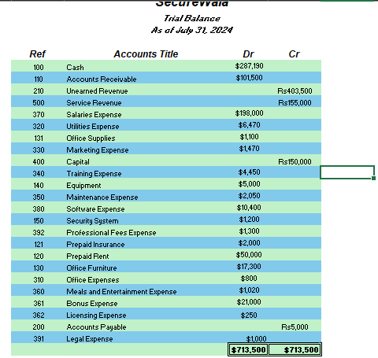

# ADJUSTING ENTRIES AND ADJUSTED TRIAL BALANCE

## Adjusting Entries

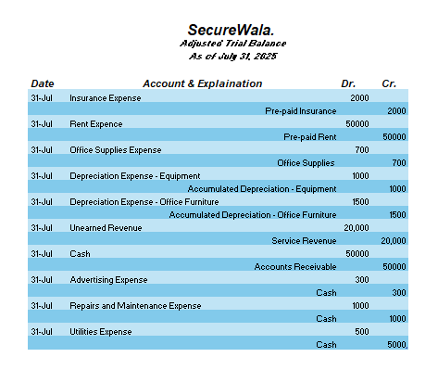

## Adjusted Trial Balance

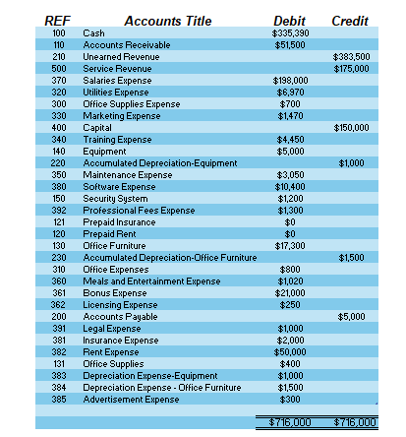

# FINANCIAL STATEMENTS

## INCOME STATEMENT

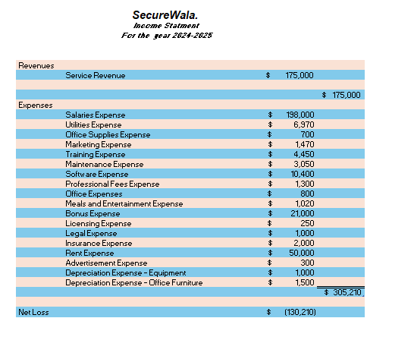

## OWNER’S EQUITY STATEMENT

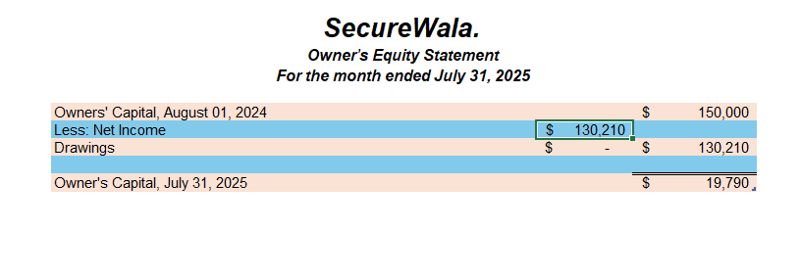

## BALANCE SHEET

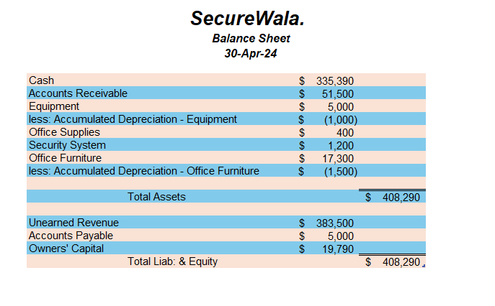

# CLOSING ENTRIES ,T-Accounts AND POST-CLOSING TRIAL BALANCE

## Closing Entries

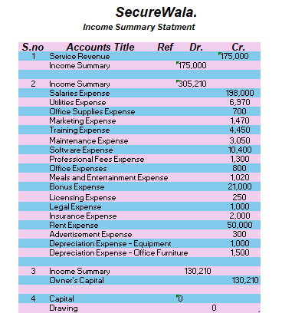

## Closing T-Accounts

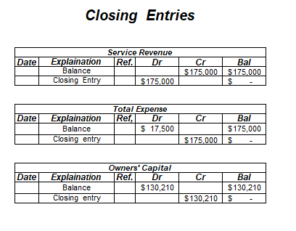

## Post-Closing Trial Balance

